* **Unit/Integration Test results after fixing the reported second bug: -**

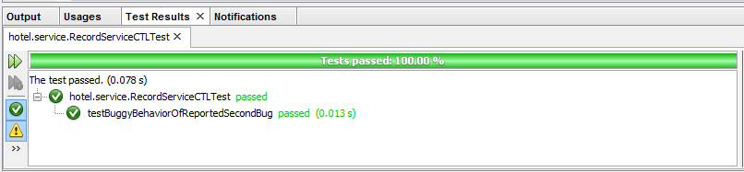

## Figure 31

* **Output of the system after fixing the reported second bug: -**

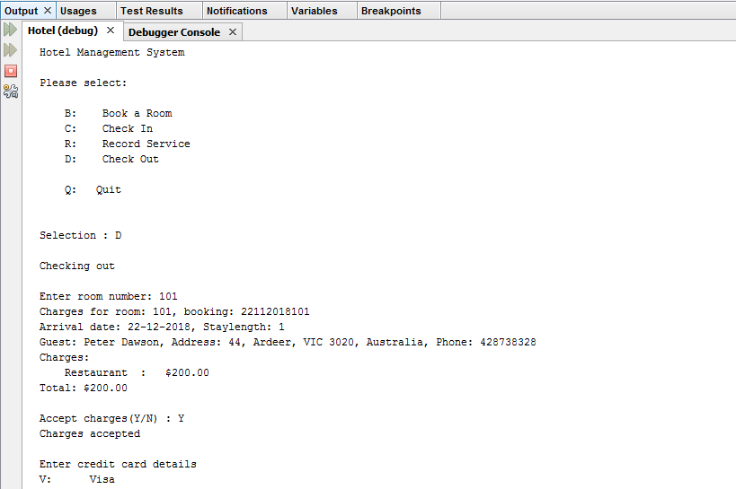

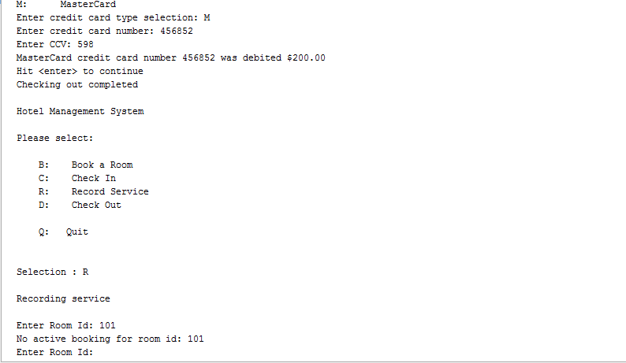

## Figure 2